TBW Book Exercises (Page 60 and 61)

Worksheet Tasks

21K-3153

21K-3372

**Book Exercises:**



**Page 60 & 61:**

**Research Problem of the Abstract:**

The project aims to analyze the benefits of partitioning the artificial intelligence of board games into software and hardware to improve performance and energy efficiency, leading to more battery-aware applications.

**Motivation:**

Board games provide weak play on smartphones and tablets due to their lower computational power and limited power budget. This project aims to tackle this problem by using hardware/software codesign to design games that are both power and energy efficient whilst improving user experience.

**Name the games the study worked with:**

Reversi, Blokus and Connect6

**Strengths of the study:**

The results show that the strengths of the study are its hardware/software codesign approach to designing board games. These games not only sustain the user experience of playing board games on desktops, but also improve on it. Moreover, these games are power and energy efficient as well, making them optimal for smartphones and tablets.

**The research problem of Abstract 2:**

The research problem is addressing the transformation of stock trading from Wall Street to Internet Client server technology with advancements in ICT. To this end, a trading program, JTrade, has been made in Java with a multitude of features previously only in the hands of stockbrokers to facilitate independent stock broking.

**Sources used in Abstract 1:**

3 sources, namely material from research in software engineering and trustworthy computing, public FDA data and accident reports are used to understand the risks and benefits of medical device software.

**Motivation of Abstract 2:**

In the past, stock trading facilities were only available to Stock Exchange and Brokerage Firms located at Wall Street. Anyone interested in stock trading had to deal with brokers’ fees and service limitations. However, with advancements in ICT, anyone can trade stocks without those hassles. JTrade wants to use these advancements to facilitate independent stock broking by providing functionalities to its users that were previously only available to brokers.

**Recommendations in Abstract 1:**

1. Regulatory policies that specify outcome measures rather than technology
2. Collection of statistics on the role of software in medical devices
3. Establishment of open-research platforms for innovation
4. Clearer roles and responsibilities for the shared burden of software
5. Clarification of the meaning of substantial equivalence for software
6. Increase in FDA’s access to outside experts in software

**Functionalities of JTrade:**

Portfolio management, charting, technical analysis, paper trading, genetic programming, equation storing, quotes storing, graphical stock analysis, low-cost transactions, and real-time market information.

**WORKSHEET**

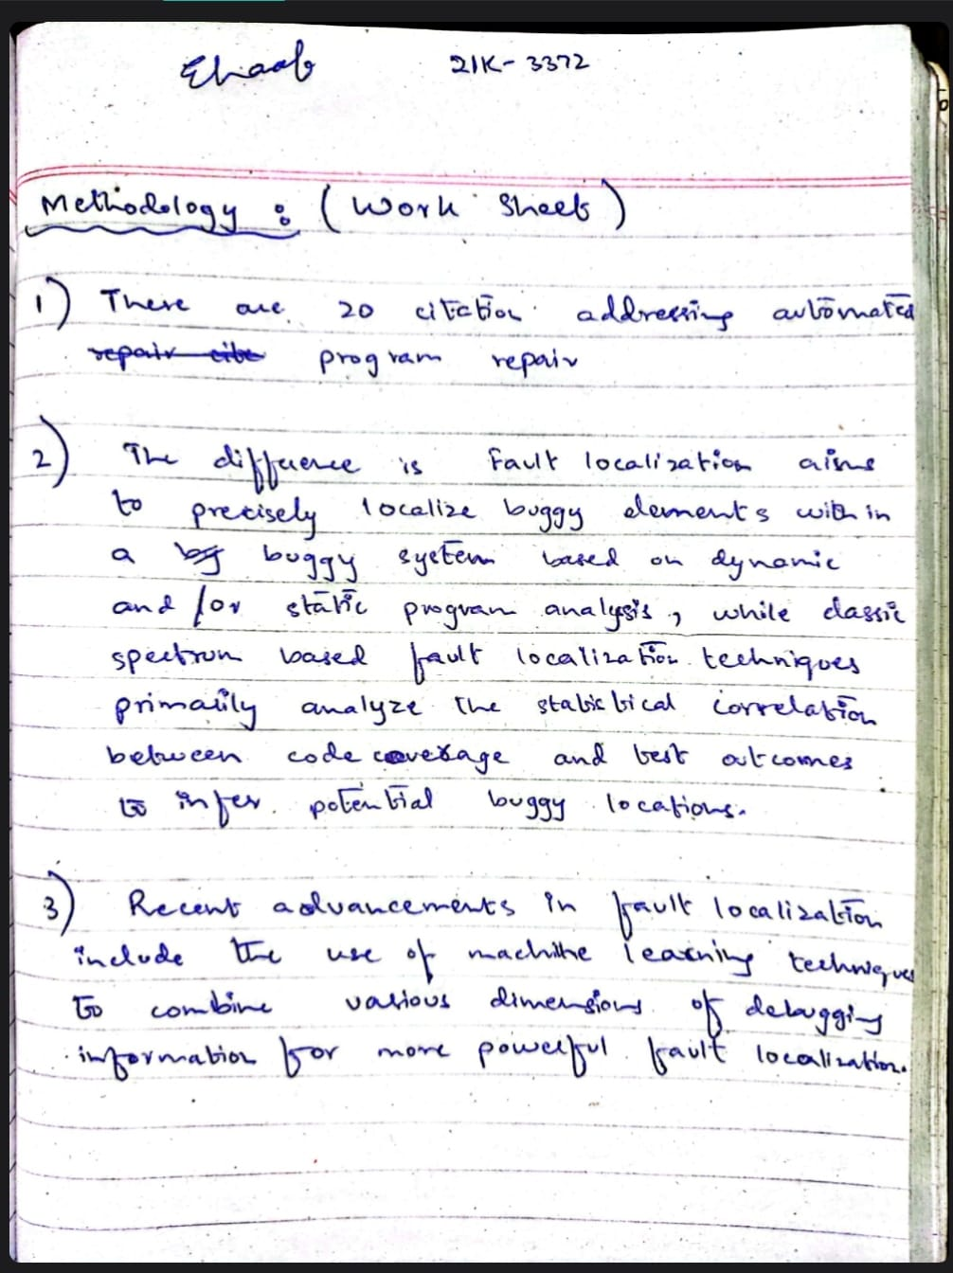

**Requirements for a canteen ordering system:**

1. Each user should have their own account (Login Facility)
2. Each user should have their order history available.
3. Each user should be able to browse food items, view their price and add items to cart
4. Each user should have the option pay by either cash or card
5. Each user should be able to see the opening and closing times of specific stalls

**Descriptive Definition of NodeJS**

NodeJS is an open-source environment that allows JavaScript code to be run outside of a web browser. It is an extremely versatile server-side scripting language, used to build the backend of websites and network applications. It is built on the same engine as Google Chrome and specializes in handling concurrent operations due to its non-blocking I/O model. It is often used in conjunction by ReactJS (for frontend) and MySQL or MongoDB (Database management) to build high quality network applications.

**Use Case diagrams:**

A Use Case diagram visualizes interactions between users and a system. Users are “Actors” who interact with the functionalities of a system, called “Use Cases”.

**Facebook services integrated into an e-commerce website:**

A Facebook service is developed for Daraz to facilitate higher sales and easier interactions between users and vendors. This service is integrated with the Facebook website and uses Facebook APIs. The Facebook recommendation algorithm uses user posts to recommend products that suit the specific needs of a user. Facebook’s messaging functionality ensures smooth and reliable communication between vendors and users. Users can follow their favorite vendors and keep track of new stock through vendor posts.

**Writers Recommendation for Future Research:**

To address and achieve the goal of generality for search query encoding in all domains, richer programs, such as those that use for loops and other complex constructs need to be considered along with programmers who use this approach in their daily work.

**Implementation Steps:**

1. Take input/output in textual form.
2. Transform in constraints as illustrated in Section 1.
3. For each program in the repository, identify input and output.
4. Encode input/output symbolically.
5. For Java statements, LHS is output and RHS is input.
6. For pipes, specific modules (e.g. Fetch) are inputs with the Output module as an output.
7. For SQL, tables and fields referenced by the query are inputs with the final output being a table.